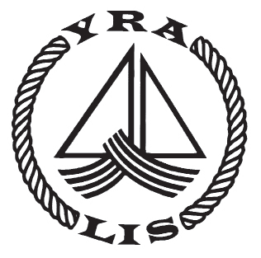
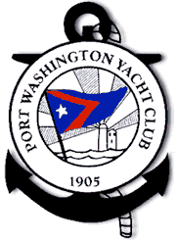
PORT WASHINGTON YACHT CLUB 70th ANNUAL YRALIS DAY RACE

NOTICE OF RACE
Sunday, June 4, 2016
This Race is a Qualifier for the YRALIS Youth Challenge Trophy
Rules The regatta will be governed by The 2017-2020 Racing Rules of Sailing and the prescriptions of the Yacht Racing Association of Long Island Sound (YRA LIS), except as any of these are changed by the sailing instructions.
Eligibility and Management Open to single-hull yachts whose owner is a member of the YRALIS or recognized yacht club or association affiliated with the US Sailing Association. The race will be managed by the Race Committee of the Port Washington Yacht Club. Official announcements by the Race Committee on VHF channel 74 will supersede the sailing instructions. We will be racing using both PHRF and IRC scoring systems at the discretion of the Race Committee. All boats must submit with the application a current YRALIS PHRF certificate. The fleet shall be divided into classes according to a yacht’s PHRF or IRC rating at the discretion of the Race Committee. A special non-spinnaker class will be included for auxiliary boats. To be eligible for the YRALIS Youth Challenge Trophy at least one third of the crew must be between the ages of 14 and 24, as of the day of the Start. Designation as a non-spinnaker yacht must be made by the yacht owner or skipper by the registration deadline on Saturday June 3, 2017 at 5 p.m.
Entry Fees $65.00 (Included is a BBQ for skipper plus 8 crew members after the race. Additional wristbands for the BBQ can be purchased for $10.00 each.) Entries will not be accepted after 5:00 PM, Saturday, June 3, 2016. Registration at YachtScoring, www.yachtscoring.com. Sailing Instructions will be available on YachtScoring and at PWYC before the race.
Start The first warning signal will be at 1155 on Sunday, June 4, 2017.
Prizes/Awards BBQ First place prizes will be awarded in each division. Second place prizes will be awarded for divisions with five starters. Third place will be awarded for divisions with six starters. Race results will be announced following the race at the P.W.Y.C. no earlier than 2 p.m. and ending at 7 p.m. Prizes will be awarded at a BBQ at the PWYC immediately following the race. Soft drinks and a keg of beer will be provided for sailors. A cash bar will be available for those who choose other beverages. Please contact the P.W.Y.C. dock facilities at VHF ch. 74 or tel. (516) 767- 9749 for mooring instructions and launch service.
Disclaimer of Liability Competitors participate in this regatta entirely at their own risk. See rule 4, Decision to Race. The Port Washington Yacht Club will not accept any liability for material damages or personal injury or death sustained in conjunction with or prior to, during, or after the regatta. Rule 4: Decision To Race – The responsibility for a boat’s decision to participate in a race or to continue racing is hers alone.

George Catallo, Race Committee Chair, gtcatallo@gamil.com

Regatta Chair Tom Egan, PRO
Port Washington Yacht Club - One Yacht Club Drive - Port Washington, NY 11050 racecommittee@pwyc.com - 516-767-1614 - www.pwyc.com

