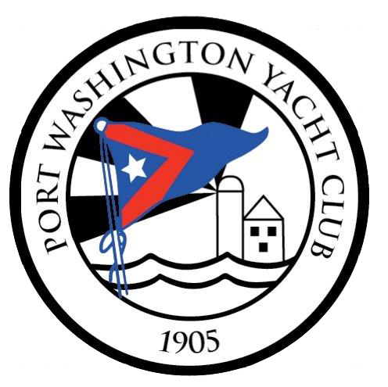

Rules
PORT WASHINGTON YACHT CLUB
18th Annual Charity Cup Regatta

Oct 7, 2017
to benefit

SAILING INSTRUCTIONS (PHRF)

The Racing Rules of Sailing and the prescriptions of the Yacht Racing Association of Long Island Sound (YRALIS) will govern the regatta, except as any of these are changed by the sailing instructions.

Eligibility
  - Open to single-hull yachts whose owner is a member of the YRALIS or recognized yacht club or association affiliated with the US Sailing Association. The race will be managed by the Race Committee of the Port Washington Yacht Club. (Ideals and Lasers, see the Cow Bay SI).
  - Official announcements by the Race Committee on VHF Channel 74 will supersede the Sailing Instructions.
  - All boats must submit with the application a current YRALIS PHRF certificate. The fleet shall be divided into classes according to a yacht’s PHRF rating at the discretion of the Race Committee.
A special non-spinnaker class will be included for auxiliary boats.
  - Designation as a non-spinnaker yacht must be made by the yacht owner or skipper by the registration deadline on Friday Oct 6, 2017 at 5p.m.

Course

Courses will be designated by code flag A, B or C as follow:

Course A Bell “21” North of Matinecock Point to Nun “40A” South East of Scotch Caps to Gong “1” East of Hart Island to FINISH
All marks to port. Distance is 14.8 Nautical Miles

Course B Bell “21” North of Matinecock Point to Nun “40A” South East of Scotch Caps to Gong “1” East of Hart Island to
Nun “2” North East of Willets Point to Gong “29” North of Hewlett Point to FNINSH
All marks to port (except Gong “29”). Distance is 20.25 Nautical Miles
Course C Nun “2” North East of Willets Point to R “2” South of Hens and Chickens to Gong “1” East to Hart Island to
FINISH
All marks to port (except R “2”). Distance is 17 Nautical Miles

Alternative Course
In the event of foul weather and solely at the discretion of the Race Committee, an alternative course starting off Hewlett Point may be utilized. Designation of the Alternative Course will be by code flag D and notice broadcast on VHF Channel 74 not less than 30 minutes prior to the scheduled start of the first division.

Alternate Course D Start Area South East of G “29” North of Hewlett Point
(in Manhasset Bay)
Red/Green South West by W of Execution Rocks Light to Nun “46A” North West of Steppingstones Light to
G “29” North of Hewlett Point to FINISH
All marks to port (except G “29”). Distance is 7.85 Nautical Miles

- Government Marks
Except for marks designated as marks of the course, all Government marks and aids to navigation may, at the Skipper’s discretion and responsibility, be passed to either side.

Starting Time and Signals
A pre-warning signal for the first division will sound at approximately 11:50 am. At approximately 11:55 the warning signal for the first division will sound. Class Flags will be numerical flags. See Scratch Sheet for Division breakdowns. A rolling five minute start sequence may be used as follows:

SIGNAL | MIN. | FLAG | SOUND
Warning | 5 | Class Flag Up | 1 Sound
Preparatory | 4 | Blue or “P” or “I” or “Z” or “Z/I or “Black” up | 1 Sound
One Minute | 1 | Preparatory Flag Down | 1 Sound
Start Warning | 0 | Class Flag Down | 1 Sound

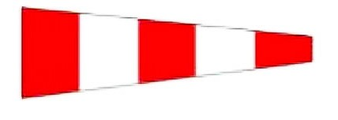
Starting Line
Postponements will be signaled by the Answering Pennant “AP” and two sounds. The next signal will be the Pre-warning Signal, approximately 1 minute before the warning signal for the next division not yet started

The Starting Line is between Green Can “C1” North of Execution Rocks Light and the Committee Boat for all courses other than Alternative Course D. See “alternative Course” above.

Recall and General Recall
Individual Recalls will be signaled by code flag “X” and a horn blast. Sail numbers of recalled yachts will be announced by the Race Committee by broadcast over VHF Channel 74.
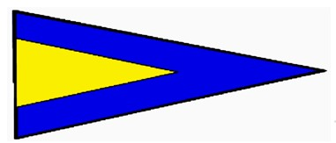
General Recalls will be signaled by the First Substitute and two sounds. The next signal will be the Warning signal for the Division recalled.

The Finish
The Finish Line will be located in the area between Hewlett Point and Barker Point at Manhasset Bay.

Time Limit
To be scored as finished, a yacht must finish within 5 hours of its division starting time. No yacht will be scored as finished after 6:00 pm.

Entry Fees
  - $75 (includes a BBQ for skipper and 8 additional crew members after the race). Additional wrist bands for the BBQ will be available for $10.00 each.
  - Entries will not be accepted after 5:00 pm on Friday Oct 6, 2017. To enter, go to www.yachtscoring.com.

Protests
Protests shall be submitted in writing on official forms provided by the office of Port Washington Yacht Club, One Yacht Club Drive, Port Washington, NY no later than 2 hours following the time of the last boat’s finish. Protests will be heard at 7 pm on the Wednesday following the race at PWYC.

Prizes/Awards BBQ
First place prizes will be awarded in each division. Second place prizes will be awarded for divisions with five starters. Third place will be awarded for division with six starters. Race results will be announced following the race at PWYC no earlier than 2 pm and ending at 7 pm.

Disclaimer of Liability
  - Competitors participate in this regatta entirely at their own risk. See Rule 4, Decision to Race. The Port Washington Yacht Club will not accept any liability for material damages or personal injury
or death sustained in conjunction with or prior to, during, or after the regatta.
  - Rule 4: Decision to Race: The responsibility for a boat’s decision to participate in a race or to continue racing is hers alone.

Port Washington Yacht Club
One Yacht Club Drive, Port Washington, NY 11050 Phone: (516) 767-1614 Fax: (516) 767-3531
www.pwyc.com
Aidan McCormack: Charity Chair
Tom Egan, Jr. - Principal Race Officer
PWYCRC@gmail.com

