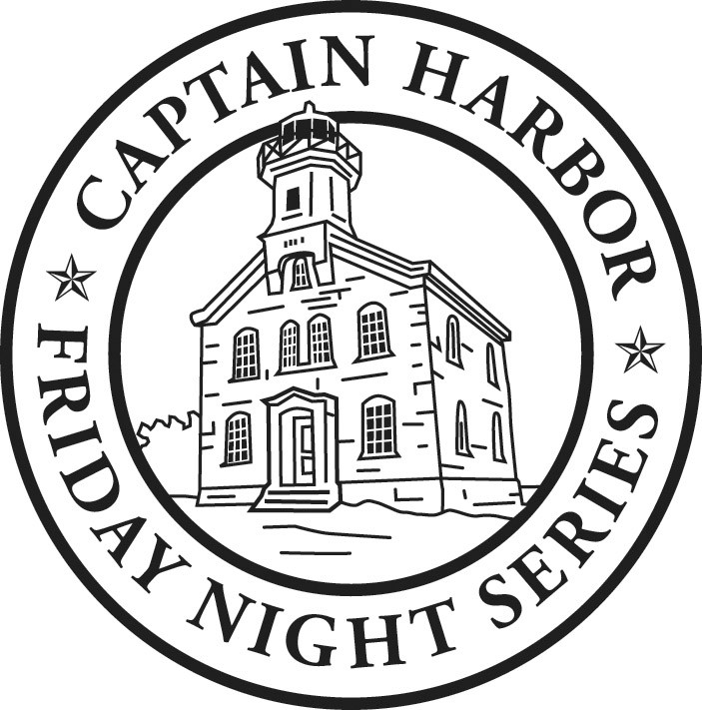

GREAT CAPTAIN TEAM TROPHY

TEAM DECLARATION

YACHT CLUB:_________________________

Boat Name Sail Number Division

- ____________________ __________________________ __________________________

- ___________________ _________________________ __________________________

- ___________________ __________________________ _________________________

____________________________ ____________
Signature of Team Captain Date

GREAT CAPTAIN TEAM AWARD

The award was established in 2009 to celebrate the 5th anniversary of the Captain Harbor Friday Night Series in Greenwich, CT. The trophy will be awarded to the club of the team with the lowest combined series score. The winning club will display the perpetual trophy. Each team shall consist of three boats from the same club. A boat can participate on only one team.

Please submit the completed form to the Sailing Director or designee at Indian Harbor Yacht Club by 5:00 pm the day before the 1st race.

Indian Harbor Yacht Club
710 Steamboat Rd, Greenwich CT. 06830
p.203.869.2484 f. 203.869.0135
sailing@indianharboryc.com

